**222222222222222222222222222222222222222222222222222222222222222222**Fast

**FAST- National University of Computer & Emerging Sciences, Karachi.  
Department of Computer Science  
Quiz- I, Fall 2019**

**20th September 2019**

|  |  |
| --- | --- |
| **Course Code: CS 211** | **Course Name: Discrete Structures** |
| **Instructors: Mr. Shoaib Raza** | |
| **Student Roll No:** | **Section:** |

**Time Allowed: 01 Hour. Maximum Points: 30 points**

**Question #1: (02 points)**

**Let p and q be the propositions**

**p: It is below freezing. q: It is snowing.**

**Write these propositions using *p* and *q* and logical connectives (including negations):**

1. **It is not snowing if it is below freezing. p  ¬ q**
2. **That it is below freezing is necessary and sufficient for it to be snowing. P** ↔ **q**

**Question #2: (04 points)**

**Prove the following logical equivalence using the laws of logic:**

**p → (¬ q ∧ r) ≅ ¬ p ∨ ¬ (r → q)**

**Solution:**

**= ¬ p ∨ ¬ (r → q)**

**= ¬ p ∨ ¬ (¬ r v q) Implication Law**

**= ¬ p ∨ (¬ (¬ r) ∧ ¬ q) De-Morgan Law**

**= ¬ p ∨ (r ∧ ¬ q) Double Negation Law**

**= ¬ p ∨ (¬ q ∧ r) Commutative Law**

**= p → (¬ q ∧ r) hence proved**

**Question #3: (02 points)**

**Let P (x, y) means “*x + y =* 0”, where x and y are integers. Determine the truth value of the statement. Show steps of calculation.**

**a) ∀x ∃y ¬ P (x, y)**

**Solution: True ¬ P (x, y) = x + y ≠ 0 x + y ≠ 0 + 1 ≠ 0 and x + y ≠ 1 + 1 ≠ 0**

**Question #4: (04 points)**

**Suppose the variable x represents all adults in your neighborhood.**

**P(x): x knows kung Fu. Q (x): x knows karate.**

**R(y): y Knows karate. S(y): y knows Kung Fu.**

**Write the statement in good English without using variables in your answers.**

1. **∃x (p(x) ∧ ¬ Q(x))**

**Solution: There is an adult in your neighborhood who knows Kung Fu but not Karate.**

**Write the statement using the above predicates and any needed quantifiers:**

1. **No adult in your neighborhood knows kung Fu and karate.**

**Solution: ¬ ∃x (p(x) ∧ Q(x)) = ∀x ¬ (p(x) ∧ Q(x)) = ∀x (¬ p(x) ∧ ¬ Q(x))**

**Question # 5: (04 points)**

**Write the name and rule of inference which is used in each argument below?**

**a)** **If it is rainy, then the pool will be closed. It is rainy.**

**Therefore, the pool is closed.**

**Solution:**

**Modus Ponen p  q**

**P_____**

**q**

**b) If it snows today, the university will close. The university is not closed today.**

**Therefore, it did not snow today.**

**Solution:**

**Modus Tollen p  q**

**¬ q_____**

**¬ P**

**Question #6: (04 points)**

**Use set-builder notation and logical equivalences to establish the De Morgan law.** 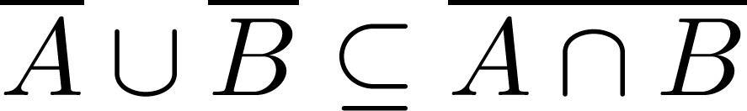

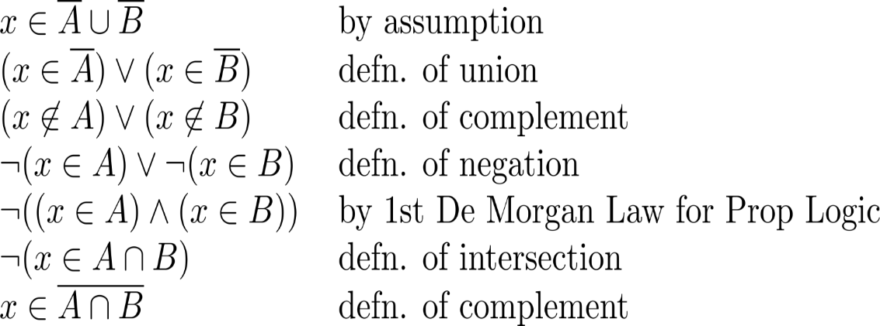

**Question #7: (04 points)**

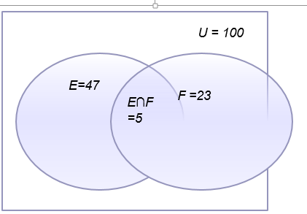**There are 100 students in a class, 47 are learning English and 23 are learning French Language whereas 5 learning both languages. How many learning either and how many learning neither? Show proper steps of computation and also draw Venn diagram.**

**Solution:**

**Total number of students, n(µ) = 100**

**Number of English language students, n(E) = 47**

**Number of French language students, n(F) = 23**

**Number of students who learning both, n(E∩F) = 5**

**Number of students who learning either of them,**

**n(EᴜF) = n(E) + n(F) – n(E∩F) = 47+23-5 = 65**

**Number of students who learning neither = n(µ) – n(EᴜF) = 100 – 65 = 35**

**Question #8: (02 points)**

**Determine whether the function from Z to Z is Injective OR Surjective. Show proper steps.**

**ƒ(n) = n2 +1**

**Solution: Surjective (onto)**

**This can be proved by an example; ƒ (1) = 2, and also ƒ (-1) =2.**

**Question #9: (02 points)**

**Let *f* be the function from {p, *q, r, s*} to {7,8,9,10} such that *f(p) =* 7, *f(q)* *=* 8, *f(r) = 10* and *f(s) =* 9. Is f invertible and if so, what is its inverse?**

**Solution:**

**The function *f* is invertible because it is a one-to-one correspondence. The inverse function *f-1*reverses the correspondence given by *f*, so *f-*1(7) *=p*, *f-*1*(*8) *= q, f-*1*(*10) *=r* and *f-*1*(*9) *=s.***

**Question #10: (02 points)**

**Let p, q and r be statements. Determine, using a truth table that statement ((p ∨ q) ∧ (¬ p ∨ r)) → (q ∨ r) is a Tautology.**

**Solution:**

|  |  |  |  |  |  |  |  |  |
| --- | --- | --- | --- | --- | --- | --- | --- | --- |
| **p** | **q** | **r** | **¬ p** | **(p ∨ q)** | **(¬ p ∨ r)** | **(p ∨ q) ∧ (¬ p ∨ r)** | **(q ∨ r)** | **((p ∨ q) ∧ (¬ p ∨ r)) → (q ∨ r)** |
|  |  |  |  |  |  |  |  |  |
| **T** | **T** | **T** | **F** | **T** | **T** | **T** | **T** | **T** |
| **T** | **T** | **F** | **F** | **T** | **F** | **F** | **T** | **T** |
| **T** | **F** | **T** | **F** | **T** | **T** | **T** | **T** | **T** |
| **T** | **F** | **F** | **F** | **T** | **F** | **F** | **F** | **T** |
| **F** | **T** | **T** | **T** | **T** | **T** | **T** | **T** | **T** |
| **F** | **T** | **F** | **T** | **T** | **T** | **T** | **T** | **T** |
| **F** | **F** | **T** | **T** | **F** | **T** | **F** | **T** | **T** |
| **F** | **F** | **F** | **T** | **F** | **T** | **F** | **F** | **T** |

***BEST OF LUCK!***